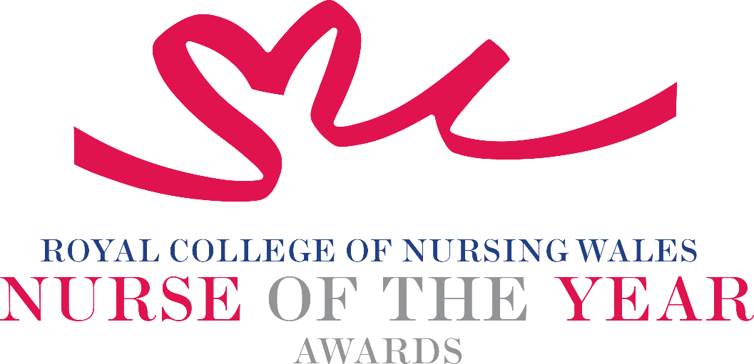

Research, Innovation and Digitalisation in Nursing
2026 Criteria

Nursing research, innovation and digital technology provide the evidence that supports nursing and midwifery practice. They matter for people of all ages and in every stage of health and care, from early years and wellbeing through to end-of-life care. Together, they help improve practice and raise the quality of care in a values-based, patient-centred way. They also help services deliver better outcomes, use resources well, and build systems that are easier to access and more sustainable.

About the award: This award seeks to recognise and reward excellence in nursing and midwifery where research, innovation or digitalisation (including preliminary work such as pilot studies, clinical audits, or service improvement) has demonstrated tangible benefits to patient care. It acknowledges nurses and midwives who have enhanced the patient experience through their evidence-based innovations which have driven and/or influenced change. These changes may have introduced the creation and implementation of digital services to complete processes. Nominators are required to submit a clear narrative detailing the development or implementation of the research, transformation, or service improvement, including the methodology used and how the changes have positively impacted the patient experience and outcomes of care.

WHO CAN BE NOMINATED?
Registrants on all parts of the NMC register who are:

- Working at any level within a clinical role or managing clinical services within Wales.
- Engaged in research, clinical audit, service improvement / innovation or digital transformation within any health care, social care or research environment.
- Practising in any sector for example: Independent Health and Social Care, Third Sector, NHS or Local Authority.
- Diversity in nominees is encouraged to reflect today’s workforce in Wales.
CRITERIA
- Their work follows national health and social care policy and strategy.
- Makes an excellent contribution to research, clinical audit, service improvements, new ideas, or digital transformation, and can show that they have put their contribution into practice.
- Has positively contributed to the development something new that has clearly made improvements for people receiving care.
- Promotes the use of evidence‑based practice when developing or introducing new ideas or innovations in their area of work.
- Actively shares research through presentations, written work, or other methods, or has contributed to research, development, clinical audit or service improvement in Wales.
- Can show that the research, innovation, or digital project they’re nominated for is safely and effectively structured and managed.
- Shows leadership that has helped raise the profile of nursing and midwifery research.
- Can show, through service evaluation, patient involvement, or other approaches, that their work has had a positive impact on the people they care for.
- They show passion and commitment for the nursing profession, consistently goes the extra mile, and maintains a positive, “can‑do” attitude.

PLEASE NOTE THAT NOMINATIONS WILL BE SCORED USING EACH OF THE ABOVE CRITERIA POINTS, INDIVIDUALLY.

TIPS FOR WRITING YOUR NOMINATION
- Consider if this is the best category to submit your nomination to, there are 14 different awards - Awards | Wales | Royal College of Nursing
- Every point you write should connect to the award criteria, this will help your nomination achieve a higher shortlisting score.
- Don’t assume reviewers will read between the lines—spell out how their work matters and how they promote positive patient care.
- Tell the reader what the headline is, what are you proud of? Use attention grabbing success stories.
- Avoid acronyms and use the spelling & grammar tool on word to check your nomination.
- Use at least 300 words but no more than 500 words.
- Make a draft with all your key points early. You can then review and write your full nomination when you have had time to consider the content.
- Speak with colleagues, gather real examples.

DRAFT NOMINATION NOTES

