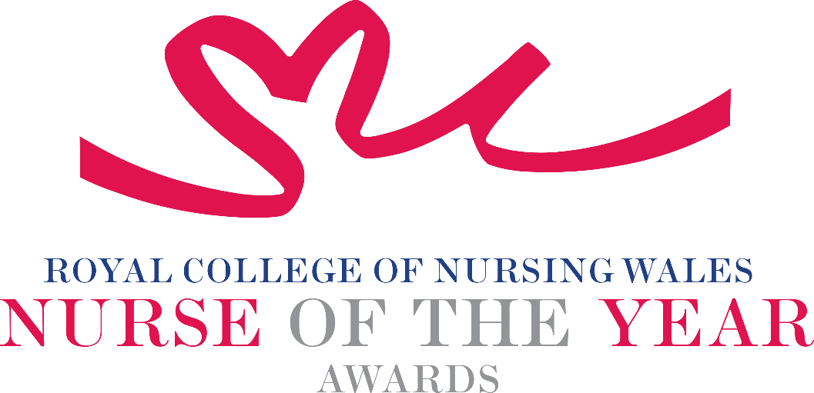

Independent Sector Nursing 2025 Criteria

This award aims to recognise a Registered Nurse or Health Care Support Worker who has made an outstanding contribution to care within the Independent Sector in Wales. Nominees will be a Registered Nurse or Health Care Support Worker committed to providing the highest quality care within the Independent Sector, to improve quality of life.

In addition to supporting the patient, the nominee will work with and support the patient’s family and/or friends, and work as part of the wider multidisciplinary team.

WHO CAN BE NOMINATED?

Either a Registered Nurse or Health Care Support Worker (who is delegated work by a Registered Nurse) who are:
- Working at any level within a clinical role
- Practising within the Independent sector
- Diversity in nominees is encouraged to reflect the workforce in Wales
CRITERIA
- Able to demonstrate that their work and approach relates to and is commensurate with national policy and strategy within health and social care
- Able to demonstrate a robust insight into the needs of the patients or service users and the impact on the family, demonstrating values that promote holistic, person-centred health and social care
- Able to demonstrate leadership skills that have positively changed or influenced care delivery
- Use of evidence-based practice to inform daily work practice
- Have participated in research-based practice, and influenced positive partnership working with individuals using services, members of the community, external agencies and other professionals
- Able to clearly demonstrate the benefits the work has had for patients, clients, families and colleagues
- Show commitment to and passion for the nursing profession, going the “extra mile” demonstrating a “can do” positive attitude

TIPS FOR WRITING YOUR NOMINATION
- Consider if this is the best category to submit your nomination to, there are 14 different awards - Awards | Wales | Royal College of Nursing
- Every point you write should connect to the award criteria, this will help your nomination achieve a higher shortlisting score.
- Don’t assume reviewers will read between the lines—spell out how their work matters and how they promote positive patient care.
- Tell the reader what the headline is, what are you proud of? Use attention grabbing success stories.
- Avoid acronyms and use the spelling & grammar tool on word to check your nomination.
- Use at least 300 words but no more than 500 words.
- Make a draft with all your key points early. You can then review and write your full nomination when you have had time to consider the content.
- Speak with colleagues, gather real examples.

DRAFT NOMINATION NOTES

